District 2203 Spain President 2023-24: |John Graham
www.marbella-guadalmina-rotary.club/
__________________________________________________________________________________
Minutes of Meeting 30 Nov 2023 at Atalaya Golf & Country Club

Attendance
Total: 21
Members: 14
Visitors: 2
Nils-Petter Hauggan, RC Oslo-Vestheim
Alexander Shrenk, RC Vogtland
Guests: 5
Valerie Schimmelmann
John Patrick Hassay
Rose Ikhisamah
Thomas Veit
Diane Morton
President John (PJ) opened the Meeting and announced there would be a raffle with bottles of wine and whisky as prizes.
Minutes Secretary Campbell (MSC) read the Invocation, was an Anglicised version of a famous Scottish grace, which definitely rhymes and scans better in Scots dialect!
‘Some have meat but cannot eat.
Some can eat but haven’t it.
But we have meat, and we can eat,
And so your God be thanked.’
He then went on to explain that November 30th is St. Andrew’s Day. Celebrated in Scotland as the country’s patron saint, St. Andrew was supposedly crucified on an X shaped cross.
The story goes that the Scots King, facing yet another larger army of marauding Anglos, saw a cross of clouds of that shape in the sky. He swore to adopt St. Andrew if they won the battle, which of course they did. Thus the white cross with the blue background became Scotland’s national flag. It forms the background of the Union Flag (Union Jack) of the UK, with the English St. George’s Cross and the Irish St. Patrick’s Cross being overlaid in red on top.
As an aside, note that the broader white stripe MUST be at the top on the quadrant nearest the top of the pole.
Sergeant-at-Arms Peter, who waited patiently while Campbell waffled on, was eventually able to declare that we were 21 in total, including two Visitors from other Clubs, and five Guests, all of whom were named and celebrated.
Thomas Veit, a former member of RC Marbella, (and a prospective Member for our Club) presented us with a pair of flags, one from RC Marbella and the other from RC Bad Krozingen in Germany. His son is the current President of Interact and his wife Susana is the SAA of RC Marbella.
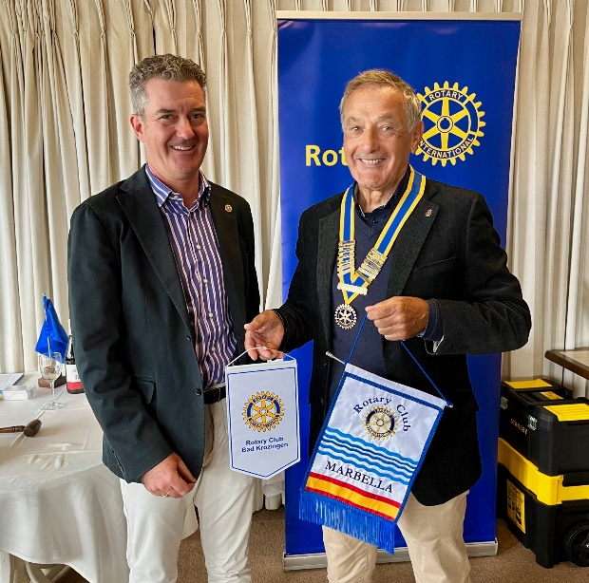
Yottie and her accomplices then mugged Members with the threat of raffle tickets for hard currency!
Ralph circulated a form on which members could confirm their orders for a name badge, with their occupation to be written thereon. He will organise delivery asap.
Martin N then spoke about the local organisation of Age Concern. While they are a voluntary group under the ‘umbrella’ of the international Age Concern organisation, the chapter we deal with here is entirely locally based and funded.
Many lonely elderly residents need and appreciate their assistance. Aiding them can be done in different ways such as through helping with administration and bureaucracy, especially where it can only be done now on the Internet. Some people just need someone to talk to.
Our local Age Concern needs approximately 10,000€ euro a year to function properly, so Members are encouraged to contribute monthly and by doing so, can obtain a Card, which entitles them to discounts with many supportive businesses, such as our corporate members IBEX.
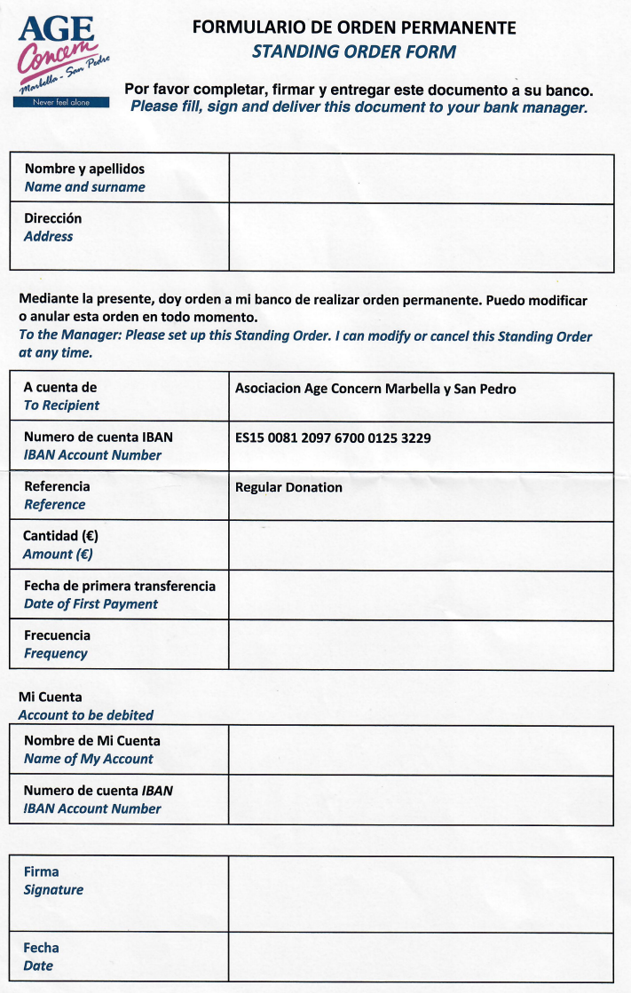

Martin N also reminded members that photos of the Swing Ball are available online. Early action is recommended as the link will expire shortly.
https://wetransfer.com/downloads/363c0586b9ceaf095e8a73be75047c9220231129171728/699028de54a96b00ca8cce58e69b265620231129171809/a6e925?trk=TRN_TDL_01&utm_campaign=TRN_TDL_01&utm_medium=email&utm_source=sendgrid
With excitement and expectations rising, Yottie drew the raffle numbers. In recognition of St Andrew’s Day, Campbell had donated a bottle of Scotch Whisky. Nils-Petter was the delighted winner, and was persuaded (conned?) by PJ that it was a Scots tradition for raffle winners to share the bottle with other raffle contributors. Many took up the offer, leaving about half the bottle for N-P to consume elsewhere. N.B. Whisky is best enjoyed at normal room temperature, with just a splash of filtered water. For the aromas and tastes to be experienced to the full, no ice, no bubbles, no mixers!
Post-whisky imbibement the Meeting went downhill rapidly with the Scots being bullied into singing a rendition of ‘Flower of Scotland’. The wannabee songsters (not!) were PJ, MSC, IK and J-P Hassay. Many a bemused face was seen in the audience.
To the relief of all an encore was not required (nor requested!) and Ian K gave an alcohol fuelled traditional toast to Rotarians the World, Universe and Multiverse over.
(The Multiverse is the hypothetical set of all Universes. Together, these universes are presumed to comprise everything that exists: the entirety of space, time, matter, energy, information, and the physical laws and constants that describe them. - Prof. Dr. Google, who knows everything.)
SUBSEQUENT ANNOUNCEMENTS
Finola and Jane have asked members to remember Simon John, a long distance cyclist seeking sponsorship for his anti-slavery campaign, which we have supported in the past. Sadly, 60% of the way through his latest journey, he was knocked down by a bus, resulting in serious health issue. Any assistance to his charity will be appreciated.
Injured Cyclist as determined as ever to fight slavery (caritaswestminster.org.uk)
MEETINGS: 7th December is our last formal meeting of 2023. The Club will re-open on the 11th January.
Our Christmas Party is on Friday 15th December (so far 43 guests and counting. Santa is rumoured to be attending), in lieu of a Meeting on 14th December.
Minutes by Campbell (Fergie) Ferguson. Edited by Ian K.

