Minutes of Board Meeting
6 October 2022

Topic | Details | Action
Events – Great Gatsby | Proving difficult to organise  No orchestra or dancers in Marbella  Stephen - Could use recorded music  (some maybe out of copyright or contact https://pplprs.co.uk/themusiclicence/ ) | Jeanne will organise a meeting end Oct/start November
Events – voting on commitment | Ask club to vote on commitment for events that involve a non-refundable deposit
Voting for charity donations | The club has traditionally voted for anything over 1000 €
Speakers | We need two speakers every month. Get each member to suggest two speakers via an online form.  IK volunteered to step in as a speaker. | JC to organise and give to Peter/Martin.  See Appendix 1 – do you want to add anything?
Membership | Robert Cazan has returned and is paid up  Thompson will be pinned next week  Jane and Yottie are being interviewed  We are on track for 40 members this year
Finance | Sophie has sent reminders and some people have paid their memberships fees.  The restaurant has accidentally been paid 630€ twice.  Cheques need two signatures | Stephen/ Sophie?  Willem visits the bank to be set up as signatory
AGM | Will be Thursday 10 November  Notice of AGM needs to be sent out 4 weeks in advance, (NOW) with nomination forms, proxies etc. | Secretary  See Appendix 2 for procedure
Club pull up Banners | They are in a bad state and two new ones are needed – a general RC M-G and an EPS one.  Some thought needs to go into the design re colours and images. Must be sturdy and suitable for use outdoors.  We need a hi-res Club/EPS lock up logo – existing one is poor quality | See Appendix 3 for some options – need proper design  Costings  Ask Martin N  IK and Stephen  Willem
Event/ Activity for Polio? | World Polio Day is Monday 24 October  Willem will check on Presidents WhatsApp if other clubs are doing anything and if we can join in | Willem
Club logo polo shirts | Still outstanding – Martin H was to organise  Have some EPS Rotary T shirts  IK suggested buying badges that people could put on their own clothes | ?
Aloha Interact | We are still technically their sponsoring Club but Estepona organised their CoC.  Lorraine and Pamela to get in touch and clarify | Lorraine and Pamela
Co-operative Events with other Clubs | Discuss at Presidents lunch on 17 Oct  Share dates for our events  Discuss division of labour and money  (Jeanne not in favour of co-ops). Peter mentions Marbella East as a possibility. | Willem
New Club venue – Villa Padierna Racquet Club | Meeting to check out the venue (Costalita) Tuesday 11th at 12.30  Racquet players not there between 2-5 pm  There is a good TV system  Peter suggests paying 28-29€ for good quality  Start online payment if there is one inclusive price  If venue acceptable, the Club meeting on 20 October could be held there  NOTE we have Begonia as a speaker on the 20th | Board and others

Joanna Chrzanowska
6 October 2022

Appendix 1
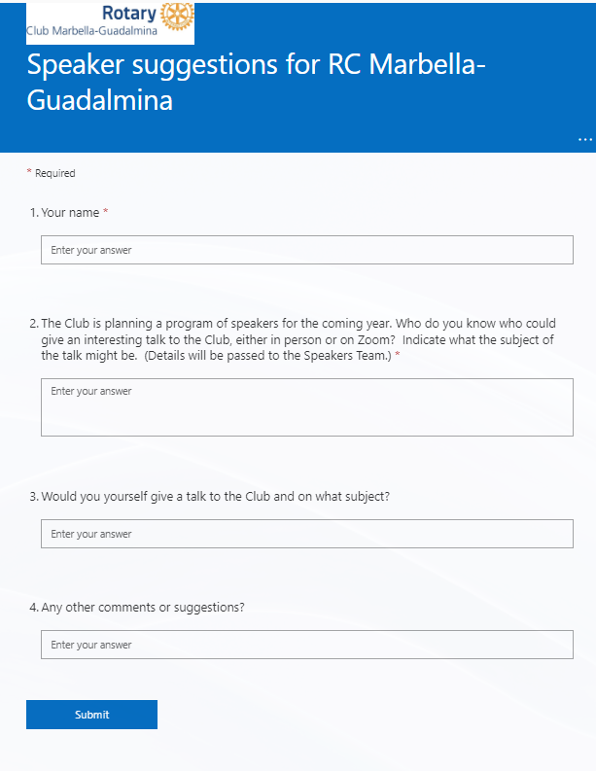

Appendix 2

Procedures for Marbella-Guadalmina Annual General Meetings
The Annual General meeting (AGM) is an important event for the Marbella-Guadalmina Rotary Club. It gives our members and the Board a broad overview of the Club's current directions, financial health and further confirms its purpose. It is also the time to revitalise the organisation through the official engagement of Members into key elected positions.
Most importantly, the Club should try to make the AGM a positive experience where people go away firmly committed to Rotary and its goals.
Benefits of holding an AGM
An annual general meeting will assist our Club to:
- Elections
At the AGM we need to elect the key office-bearers of the Club; the new President, Secretary and Treasurer for the forthcoming year; also, at that time volunteers for other Board and management committee positions for the forthcoming year should be sought.
Presentation of Accounts
The Annual Accounts should be presented to the members in an agreed ‘standard’ format. These accounts should be audited prior to the meeting by a third party in order to provide assurance to Members that nothing has been overlooked.
Documentation
The Club needs to be accountable to Rotary and our Members. This is our opportunity to report on the results of our strategic plan. Did we achieve all your expected outcomes over the past year and as a result what should we recommend doing in the next year.
- Communicate with members
The AGM provides a good opportunity for the Board to interact with the membership - to answer their questions and seek their views. Members are able to raise their concerns and participate. There should, of course, be opportunities for Members to be involved throughout the year, but the AGM provides a safety net to make certain that all views are discussed and evaluated.
Preparation for an AGM
The AGM is usually organised by the Secretary, with assistance from the rest of the Board, but this can be altered if someone else volunteers. It is important, though, that everybody in the organisation knows who is responsible.
Date
The date and timing of the AGM should be set by agreed Rotary and Club rules.
Notice
All members should be informed of the forth coming AGM by giving four weeks prior notice by mail or email, giving the place, date and time of the meeting.
Board Positions We should confirm which of our current Board will be stand for re-nominating for the coming year and who will be retiring and check our constitution to see if anybody is ineligible to stand.
If there are vacancies, we must make sure that we have approached people who are willing to fill them and remember that there may be people who come forward at the meeting itself.
Most importantly, we should try to ensure that we have enough good nominations to fill the available positions.
If people are to be nominated in their absence they must sign a document saying that they are willing to stand.
Auditor
The Treasurer should leave enough time for the Auditor to go through our Accounts and prepare his report. We should also have a nomination ready for the position of next year's Auditor putting forward somebody we have approached and is willing to act.
Meeting papers
We should prepare the following documents and post them out to all Members in advance of the meeting:
- A set of accounts - balance sheet and financial statement - in the required format.
- Annual Report
The organisation's annual report must contain the accounts, and should contain
-a summary of the year's activities
-a record of the year's achievements
-a preview of what is planned for the next year
-a restatement of the organisation's vision.
- Agenda consisting of:
  - Welcome by President
  - Apologies for absence
  - Acceptance of the Minutes of the previous AGM
  - Business arising from the Minutes of the previous AGM
  - President's report
  - Treasurer's report and presentation of audited financial statement
  - Election of Board Members
  - General business
  - Close
Meeting procedure
Motions
Motions must be moved:
-to accept the minutes of the last AGM
-to approve the President's report (the Annual Report)
-to approve the Treasurer's report (the Financial Statement)
Motions must be seconded, and a vote (generally a show of hands) taken.
Nominations
Nominations can be called for from the floor for Board positions - President, Secretary and Treasurer. If more than one person is nominated for any office, there must be an election for that office; such elections can be through a show of hands or by secret ballot.
Special procedural provisions
The only special procedural provisions at an AGM are that a quorum must present as per our Constitution.
After the AGM
Documentation
The Minutes should be written up shortly after the meeting. The Secretary should notify Rotary of the resulting change of officers planned for the forthcoming year.
Handover
Retiring office bearers must hand over their operations to the new person, together with all documents, stamps, bank details, etc. Retiring officers should also give their successors briefings describing key processes and current priorities and challenges.
Raise awareness
In some cases the AGM can be used to gain publicity for the Club. For example if we chose to have a guest speaker or make an announcement that may be of more general interest than just to our own membership, then we could prepare and circulate an appropriate press release.

Appendix 3

