President 2020-21: Pamela Lake

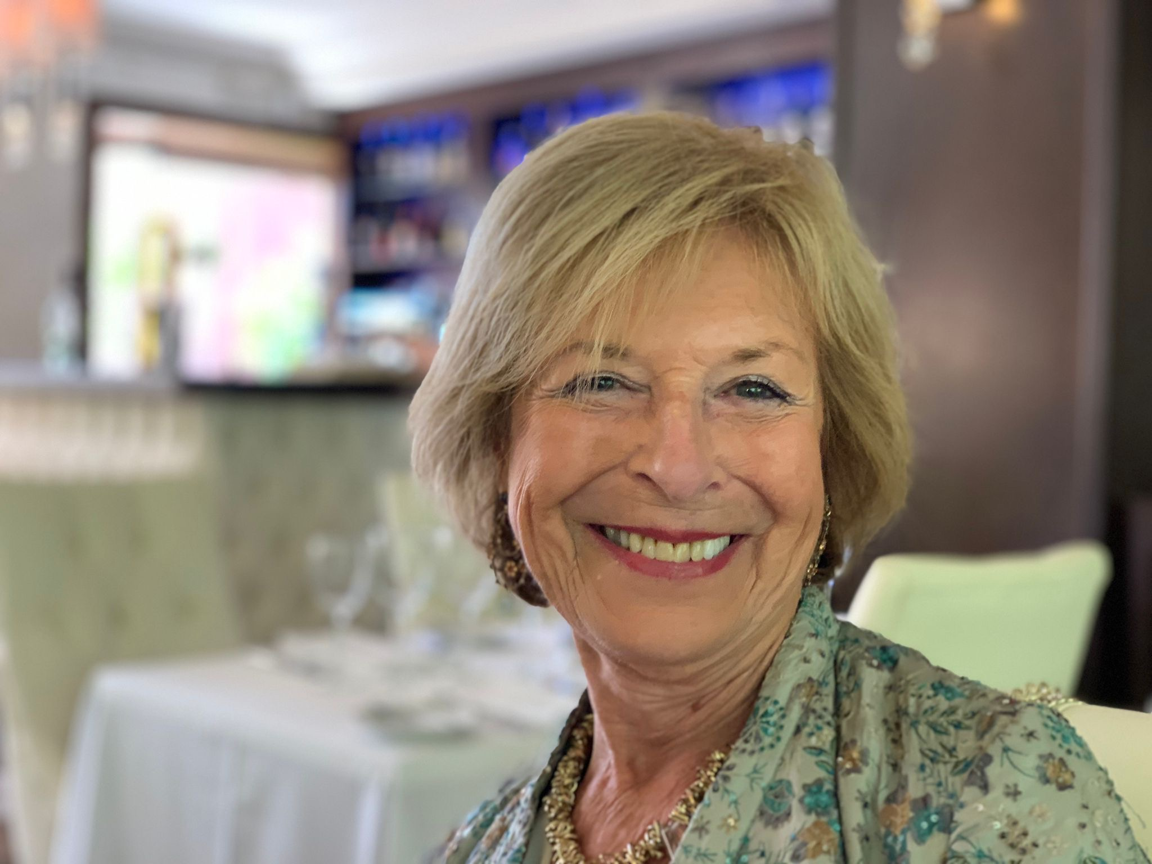
Taking over the Presidency during the Covid pandemic that continued throughout the year was quite challenging. The focus was to ensure the spirit of the club and its members.

We held 30 zoom club meetings with 13 speakers and together with some zoom fellowship evenings and a few face to face whenever possible, created some fun and ensured cohesiveness.

Some emphasis was put on creating more structure to the club in the way teams work and
coordinate so that tasks and goals could be achieved more effectively. This work is ongoing.

We have continued to reach out to other clubs and include them in some projects, especially the issue of the environment. EndPlasticSoup (EPS) for example, we organised a webinar in Marbella and organised an Action Day on 5th June to raise more awareness. More work on plastic waste is very much ongoing together with other clubs.

This year has been especially tough on the Events team who have spent time and effort on planning a number of events including some new ones that have had to be shelved until 2022. This includes a Guitar Concert/Festival, the Golf Competition to name just two.

We managed to achieve serving 11 different charity projects that have included working with orphanages, helping those ‘care leavers’; providing food for various charities in greatest need, providing equipment for those needing physical help; giving emergency donations, helping Age Concern; equipment for emergency Covid cases in India and providing help for a centre dealing with street children in Tanzania. All for a total of over €10,500 while making sure of a sizeable amount left for 2021/22 in case of Covid restrictions preventing from us in holding planned Events to raise money.

Thanks to the Communications team we have also focussed on promoting our activities in the media which has included some 8 videos on YouTube; various news releases; 62 posts on FB. a new Projects Booklet for 2020/21, not forgetting hosting 30 zoom meetings.

All in all we have had a full year and hope 2021/22 will allow us to hold some of our planned Events and enjoy an action oriented year that hopes to welcome new applicants who have already indicated interest in joining our club.

4th August 2021

